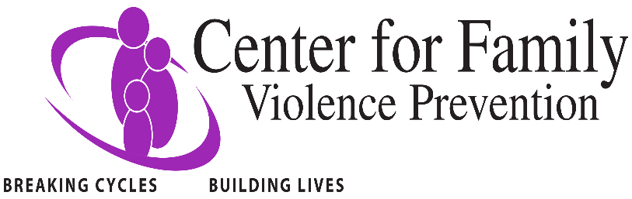
New Directions Safehouse
Job Summary: The Shelter Associate position is a part time position, up to 22 hours every other weekend. The shift is every other weekend, 8am-7pm. The Shelter Associate provides confidential, safety, and supervision services to shelter guests.
Reporting Relationship: The Shelter Associate reports to the New Directions Safehouse Supervisor.
Qualifications: The Shelter Associate position requires a minimum of an associate degree in a human services field; effective oral, written, and interpersonal communication skills, crisis management/intervention skills; knowledge of domestic violence preferred; familiarity and working knowledge of Microsoft Office, MS Word, Excel, and Outlook.
Primary Responsibilities:
- Welcome new clients entering the safe house after-hours and complete intake and exit interviews and complete all required documentation.
- Exhibit effective interpersonal skills that build mutual trust and respect with guests.
- Apply ethical standards of professional behavior in working with clients.
- Respond to the needs of residents, including distributing supplies and assistance as needed.
- Ensure residents are following shelter guidelines and responsibilities
- Answer the 24 hour crisis line, Lethality Assessment Program line and provide crisis intervention. information, referrals, and emotional support for callers
- Record case notes and documentation as required
- Clerical responsibilities as assigned
- Assure that safe house facility is clean and neat at all times
- Control access to the facility by guests, employees, and volunteers by overseeing the security system and follow all security procedures.
- Participate in 20 hours (annually) of on-going education/training to enhance service delivery skills
- Work cooperatively with all staff to achieve the mission of the agency
- Perform all other duties as needed as assigned by Supervisor or Executive Director

3/2025

